**Third Exam  Vertebrate Embryology   April 6, 2018  Your Name___________________**

1) From which germ layer is the heart derived? _______________

2) Compare and contrast an Atrial Septal Defect and a Patent Foramen Ovale

3) What are two mesodermal organs that start development as two separate groups of cells (right and left), but then their tissues fuse? ____________, ________________

4) What is the distinction between necrosis versus apoptosis?

5) What are at least five normal functions of programmed cell death (apoptosis)?

6) What are caspases?

7) Make a sketch of what Liesegang rings look like.

8) Imagine that some species of animal had in its genome 10 V sequences, 5 D sequences, and 4 J sequences. If recombination was their only method of generating antibody-binding sites, how many different shaped binding sites could they form? _____________

9) What is the error in the following misleading statement?

“Autoimmune diseases result from failure of lymphocytes to distinguish between ‘self’ and ‘non-self’ histocompatibility antigens.”

10) What misinterpretation did Wilson make in his observations about sponge cell re-aggregation?

11) When salamanders regenerate their legs, what are two fundamentally different processes that might be responsible? *Hint: they are related to Wilson's misinterpretation.*

12) How did researchers cause developing salamander legs and chicken wings to branch into three?

13) Draw a cross-section of the apical ectodermal ridge of a bird

14) What are blastemas and where are they found?

15) What causes blockage of arteries in atherosclerosis?

*16) What is this, and what is its significance? [This question was not graded, because it had not been discussed in class or in the lecture notes. It is a micrograph of fluorescent collagen from a rat being rearranged into the wall of an artery, from Stopak, Wessells and Harris (1985) Morphogenetic rearrangement of injected collagen in developing limb buds. P.N.A.S. 82: 2804-2808.]*

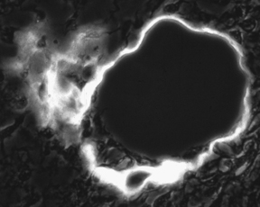

17) What class of proteins is secreted by B lymphocytes? ___________________

18) Based on your knowledge of how the immune system works, which is more surprising, that people sometimes make antibodies against molecules of their own bodies, or that everyone doesn’t always make antibodies against their own bodies. Explain your reasoning.

19) In what sense does the symmetry of the developing limb bud go from like the lowercase letter o to the uppercase letter H? *Hint: what does the AER have to do with it?*

20) What is this, and what is its significance for the mechanism of cell sorting?

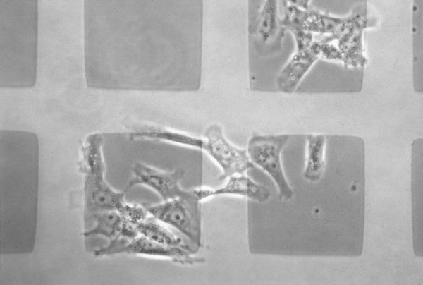

*On my honor, I have neither given nor received any unauthorized help. (sign)*